1. **Introduction**

**1.1 Problem Summary and Introduction**

Travelers faced various problems such as last moment cancellations of trips with friends, lack of knowledge about places, difficulty finding travel partners, and uncertainty about the availability of space in cars. Solo travelers often faced challenges in finding suitable travel companions. There was also no platform for travelers to connect with like-minded individuals and plan trips together. Additionally, travelers often had to switch between multiple apps and websites to book various travel-related services such as hotels, flights, and car rentals. Overall, planning and organizing a trip was often a time-consuming and challenging process for travelers. Overall, the lack of a one-stop-shop for all travel-related services and information made trip planning a tedious and time-consuming process for travelers.

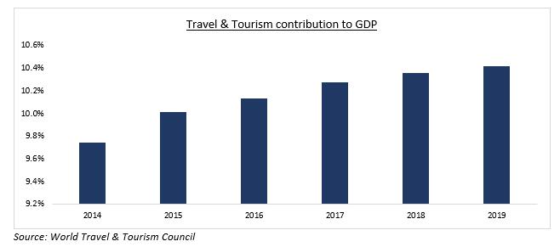

Figure 1.1 Contribution of Travel industry in GDP

Travel & tourism is a resilient sector, contributing 10.4% to global GDP in 2018 & supporting one in ten jobs. Improved connectivity, a growing middle class & tech advancement have led to insatiable demand. Mobile apps are a key driver of digital growth, with 70% of travelers using them to plan and book trips. The sector grew 3.6% in 2019, outpacing overall global economic growth for the eighth year.

Vaga Trip is a mobile application designed to connect travel enthusiasts from around the world. The app's purpose is to help travelers find new adventures, connect with like-minded individuals, and share their travel experiences. Vaga Trip offers a comprehensive platform that enables users to easily find and join trips, search for travel buddies, communicate with them in a chat box, and share their travel stories. Vaga Trip provides a comprehensive platform for travel enthusiasts to find new adventures, connect with like-minded travelers, and share their travel experiences.

The project's primary aim was to develop an Android app that serves as a travel guide for users during their journeys. Our project's objectives were to understand the basics of Android development, analyze and evaluate current trends and practices in the travel app industry, implement effective algorithms to address real-time problems, and develop a software development flow while maintaining detailed documentation throughout the process. Vaga Trip offers new functions that are not commonly found in traditional travel apps, specifically user interaction and trip sharing features.

With Vaga Trip, users can browse a variety of trips and destinations based on their interests, dates, and budget. Once a user finds a trip that matches their preferences, they can easily request to join the trip and communicate with the trip organizer in the chat box. Additionally, users can search for travel buddies based on common interests, travel destinations, and dates. This feature enables users to find compatible travel partners with whom they can share their travel experiences.

The app also includes a feature for sharing trip stories, where users can upload pictures and write descriptions of their travel experiences to inspire and inform other travelers. This feature allows users to share their unique perspectives on destinations, experiences, and cultures.

**1.2 Aim and Objectives**

The main aim of developing Vaga Trip was to create a user-friendly and comprehensive travel app that would allow travelers to easily plan and organize their trips. The app was designed to provide a wide range of features, including destination information, travel itineraries, and local recommendations, all in one convenient platform. The goal was to simplify the travel planning process and provide a seamless experience for users, from researching their destination to booking accommodations and activities. Additionally, the app aims to provide personalized recommendations and deals based on users' preferences and past travel history.

**Aims:**

1. To connect travel enthusiasts from around the world.
2. To provide a platform for users to find new adventures, connect with like-minded individuals, and share their travel experiences.
3. To serve as a travel guide for users during their journeys.
4. To enable users to easily find and join trips based on their interests, dates, and budget.
5. To facilitate communication between users through the app's chat box.
6. To provide a feature for sharing trip stories, where users can upload pictures and write descriptions of their travel experiences to inspire and inform other travelers.
7. To offer new functions that are not commonly found in traditional travel apps, specifically user interaction and trip sharing features.

**Objectives:**

1. To understand the basics of Android app development.
2. To analyze and evaluate current trends and practices in the travel app industry.
3. To implement effective algorithms to address real-time problems.
4. To develop a software development flow while maintaining detailed documentation throughout the process.
5. To ensure that each component of the app is tested to ensure it is functioning as intended.
6. To test the app's different components together to ensure the app is functioning as a whole.
7. To test the app's features and functionalities to ensure they are working as expected.
8. To conduct user testing to gather feedback and improve the user experience.
9. To test the app's performance to ensure it is fast, responsive, and stable.
10. To test the app on different devices and platforms to ensure it works on all platforms.

**1.3 Problem Specifications**

**1. Inefficient trip planning:** Planning a trip can be time-consuming and tedious, requiring users to browse through multiple websites and apps to book flights, hotels, and activities. The Vaga Trip app aims to streamline this process by providing a one-stop-shop for all travel-related needs.

**2. Limited travel options:** Some travelers may not have access to all available travel options due to language barriers or lack of knowledge about local destinations. Vaga Trip aims to expand travelers' options by providing a wide range of activities and destinations to choose from, and offering language support to ensure that all users can access the app's features.

**3. Lack of personalized recommendations:** Many travel booking websites and apps offer generic recommendations based on popularity or price, which may not align with users' preferences. Vaga Trip aims to provide personalized recommendations based on users' past travel history and preferences, in order to enhance their overall travel experience.

**4. Safety concerns:** Traveling to unfamiliar destinations can be risky, particularly for solo travelers or those with limited knowledge of local customs and safety precautions. Vaga Trip aims to address these concerns by providing safety tips and information about local customs and laws, as well as offering customer support to help travelers navigate any issues that may arise during their trip.

**1.4. Literature Review and Prior Art Search (PAS).**

1. ***"The Role of Social Media in Travel Experience Creation***" by Nima Dokoohaki and Ali Asghar Peyvandi. This paper examines how social media platforms such as Instagram and TripAdvisor are used to create and share travel experiences, and the impact of social media on travelers' decision-making processes.

2. ***"Exploring the Role of Social Media in Destination Marketing*"** by Hanqin Qiu, Joseph O'Leary, and Daniel Bauer. This study investigates how tourism organizations can use social media to promote destinations and engage with potential visitors, and explores the effectiveness of different social media strategies.

3. ***"Instagram and Tourism: A Review of Research and Trends*"** by Dan Wang, Xiang Li, and Liang (Rebecca) Tang. This article provides a comprehensive overview of research on Instagram's impact on travel behavior and destination marketing, and highlights current trends and best practices in the use of Instagram for tourism.

4. ***"The Influence of Social Media on Travel Behavior: An Empirical Investigation"*** by Julia Neidhardt and Sascha Möllering. This study examines the impact of social media on travelers' decision-making processes and destination choices, and investigates the role of social media in shaping travelers' expectations and experiences.

5. **"*Social Media and Travel: A Review and Research Agenda*"** by Ana María Munar and Wang Duan. This article provides a critical review of existing literature on social media and travel, and identifies key research gaps and future directions for research in this area.

A literature review involves identifying, evaluating, and synthesizing scholarly articles, books, and other sources related to a particular research topic. The purpose of a literature review is to provide a comprehensive understanding of the current state of research on a given topic, identify any gaps or inconsistencies in the literature, and inform the development of new research.

In the context of the Vaga Trip app, a literature review may involve researching existing travel apps and platforms, and evaluating their features and functionality. This can help to identify any gaps or areas for improvement that Vaga Trip can address. A prior art search may involve researching existing patents and patent applications related to travel apps, as well as any relevant prior art in the field. This can help to ensure that Vaga Trip's technology is novel and non-obvious, and can potentially identify any patentability issues that may need to be addressed.

1. Data analysis in terms of coding, organizing, filtering, categorizing, relating and related

abstract concepts. The software allows making comparisons among different concepts simultaneously, which simplifies qualitative data analysis and improves the accuracy of research findings. Critical strategies, including method triangulation, conformability audit and member checks are applied to ensure trustworthiness of research findings.

2. Information search (traveller’s perspectives), and market segmentation by information/booking channel. Perspective the reasons why travellers make use of different sources of information are investigated, whereas using another perspective, the observable outcome of that behaviour is raised.

3. Tour and travel information is obtained mainly through communication media like newspaper, magazines etc. Today's mobile devices are becoming more intelligent, which provides information in mobile itself. Mobile Technology is now set to improve tourism in

various fields. Due to busy schedule people want quick and easy ways to obtain information of all kinds and tourism is no different. The tour management system which is based on internet provides self-guidance for tourists in mobile phones.

**1.5. Plan of the work**

1. **Define the goals and scope of the app**: The first step in developing the Vaga Trip app is to clearly define the goals and scope of the project. This involves understanding the target audience, the features and functionality of the app, and the overall vision for the product.
2. **Conduct market research**: The next step is to conduct market research to gain a better understanding of the competition and the needs and preferences of potential users. This involves analyzing data on travel trends, researching competitor apps, and conducting user surveys and interviews.
3. **Develop a prototype**: With a clear understanding of the goals and scope of the project, and the needs and preferences of potential users, the next step is to develop a prototype of the app. This involves creating wireframes, designing the user interface, and developing basic functionality.
4. **Test the prototype**: Once the prototype is complete, the next step is to test it with a small group of users to get feedback on the user experience and identify any issues or bugs that need to be addressed.
5. **Develop the full app:** Based on the feedback from the prototype testing, the next step is to develop the full app. This involves building out all the features and functionality of the app, integrating APIs and third-party services, and conducting rigorous testing to ensure the app is reliable and bug-free.
6. **Quality Assurance and Testing:** Conduct comprehensive testing to ensure that the app functions correctly and is free of bugs and glitches
7. **Launch the app**: With the app fully developed and tested, the next step is to launch it to the public. This involves creating a marketing plan to promote the app and attract users, as well as submitting the app to the relevant app stores for distribution.
8. **Monitor and maintain the app**: Once the app is launched, the work is not over. It is important to continually monitor the app to identify any issues or bugs that arise, as well as to make updates and improvements to the app based on user feedback.

***Table 1.5 Work Breakdown Structure***

|  |  |  |  |
| --- | --- | --- | --- |
| SR. No | Name | Role | Responsibilities |
| 1 | Utsav Gohel | Junior Developer | Backend Engineer, DevOps |

**1.6. Materials / Tools required**

**Hardware requirement of the project**

* Laptop/desktop - For development
* Internet - For fetching data
* Minimum 8 GB RAM
* Minimum 16 GB Disk space

**Software requirement of the project**

1. **Programming Languages**: The Vaga Trip app was built using Flutter for the frontend and Node.js for the backend. So, proficiency in these programming languages is essential.
2. **Integrated Development Environment (IDE):** Developers working on the Vaga Trip app may use any preferred IDE such as Visual Studio Code, Android Studio, or IntelliJ IDEA.
3. **Software Development Kit (SDK):** The Flutter SDK is required to develop the user interface of the Vaga Trip app.
4. **Database Management System:** A database management system such as MySQL or PostgreSQL is required to store and manage the app's data.
5. **Application Programming Interface (API):** Vaga Trip uses the ExpressJS API with Sequelize ORM for the backend.
6. **Cloud Services:** Vaga Trip is hosted on AWS cloud using RDS as database service and EC2 Ubuntu server.
7. **Testing Tools:** Testing tools like Jest, Mocha, or Chai can be used to test the app's functionalities.
8. **Version Control System:** A version control system such as Git is necessary for managing and tracking changes to the codebase.
9. **Design Tools**: For designing user interfaces, developers may use tools such as Sketch, Figma, or Adobe XD.

**2. Analysis, Design Methodology and Implementation Strategy**

**2.1. Observation Matrix**

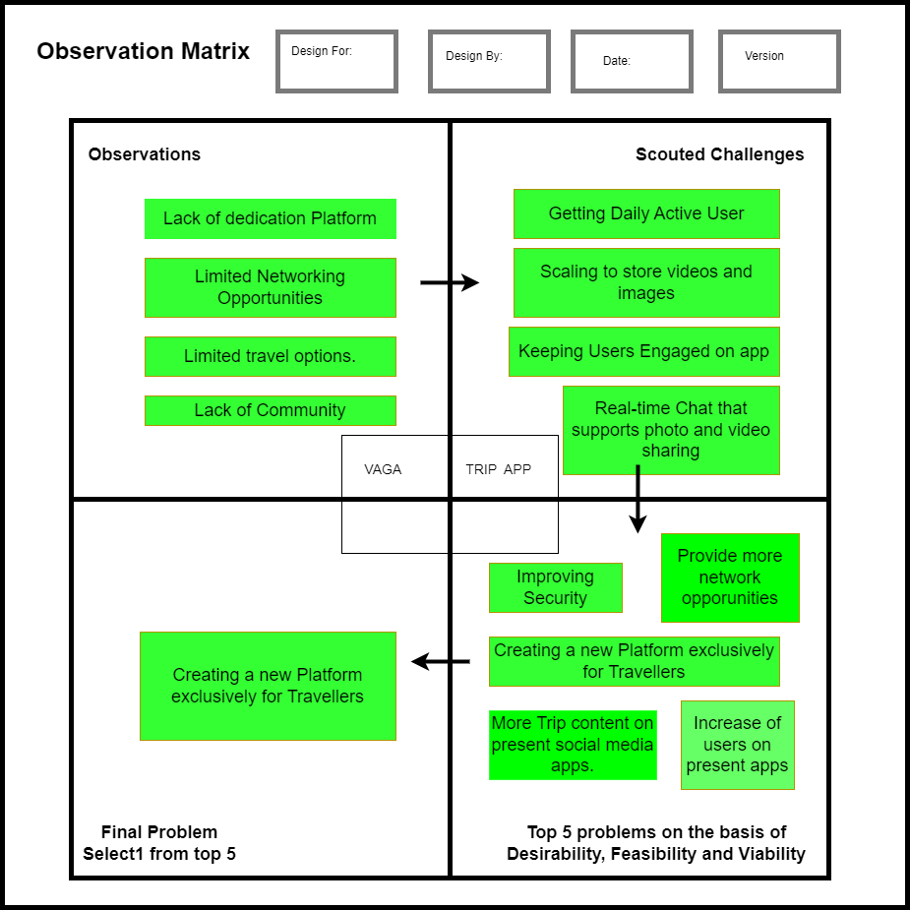

Figure 2.1 Observation Matrix

**Observations:**

The observations made while developing the app was that there is no exclusive social media app for surgeons that provides networking and peer-to-peer connection opportunities.

**Scouted Challenges:** A few challenges faced were gaining new active users as well

as removing spam users from the app.

**Top 5 Problems on the Basis of Desirability, Feasibility, and Viability:** Top

problem observed was a lack of a dedicated platform for surgeons.

**Final Problem:** As a result, we have developed and engineered an application

exclusively for surgeons

**2.2. Ideation Canvas**

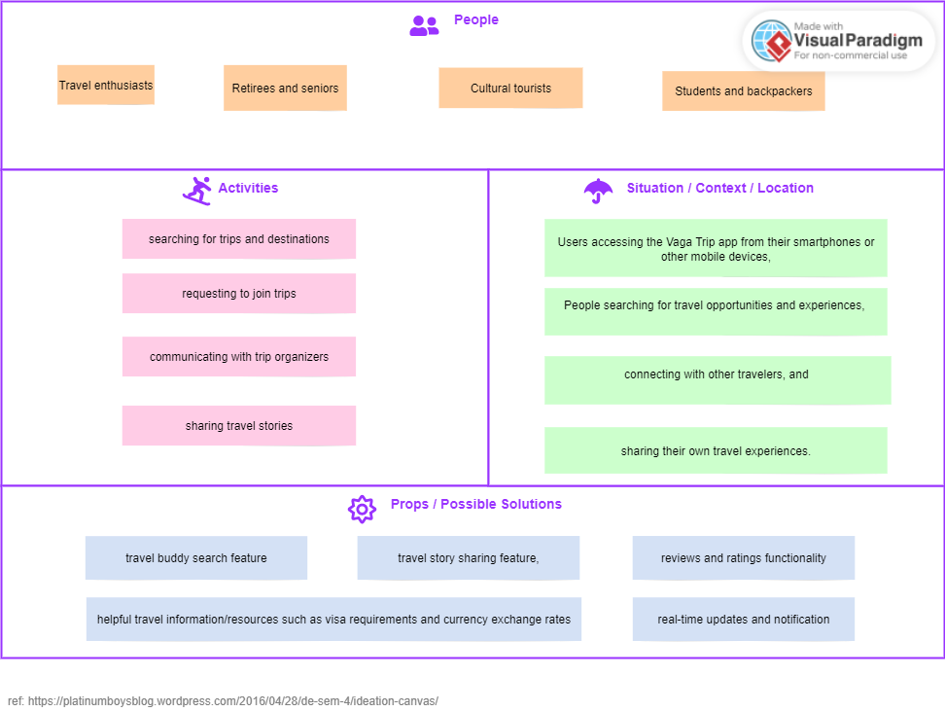

Figure 2.2 Ideation Canvas

**People**

* Travel enthusiasts
* Cultural tourists
* Students and backpackers
* Retirees and seniors

**Activity**

* Browsing/searching for trips and destinations,
* Requesting to join trips,
* Communicating with trip organizers,
* Searching for and connecting with travel buddies,
* Sharing travel stories and experiences,

**Situation/Content/Location**:

* Users accessing the Vaga Trip app from their smartphones or other mobile devices,
* searching for travel opportunities and experiences,
* connecting with other travelers, and sharing their own travel experiences.

**Props/Possible Solutions:**

* travel buddy search feature
* travel story sharing feature
* reviews and ratings functionality
* real-time updates and notifications
* helpful travel information/resources such as visa requirements and currency exchange rates.

**2.3. Product Development Canvas**

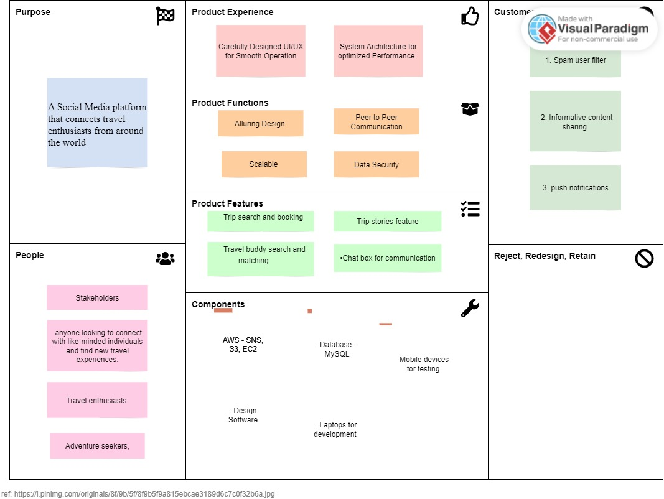

Figure 2.3 Product Development Canvas

**Purpose**

The purpose of Vaga Trip is to provide a comprehensive platform that connects travel enthusiasts from around the world, enables them to easily find and join trips, search for travel buddies, communicate with them in a chat box, and share their travel stories.

**Product Experience**

The product experience should be designed to provide an immersive and enjoyable experience for users, while also being user-friendly and easy to navigate.

The app should have a clean and modern design, with intuitive features and simple navigation.

**Product Functionality**

* The app should have the following core functionalities:
* Ability to search for trips and destinations based on interests, dates, and budget
* Ability to join and communicate with trip organizers and other travelers
* Ability to search for travel buddies based on common interests and destinations
* Ability to share trip stories and photos

**Product Features**

* Trip search and booking
* Travel buddy search and matching
* Chat box for communication with trip organizers and other travelers
* Trip stories feature for sharing photos and descriptions of travel experiences
* User profile customization
* Push notifications for trip updates and communications
* Social media integration

**Components** All the components required to create the feature we listed.

1. Database - MySQL

2. AWS - SNS, S3, EC2

3. Mobile devices for testing

4. Design Software

5. Laptops for development

**Customer Validation**

Post prototype creation is taken to the user for feedback.

1. Spam user filter

2. Informative content sharing

3. push notifications

**2.4. System Design**

**2.4.1 Use Case Diagram**

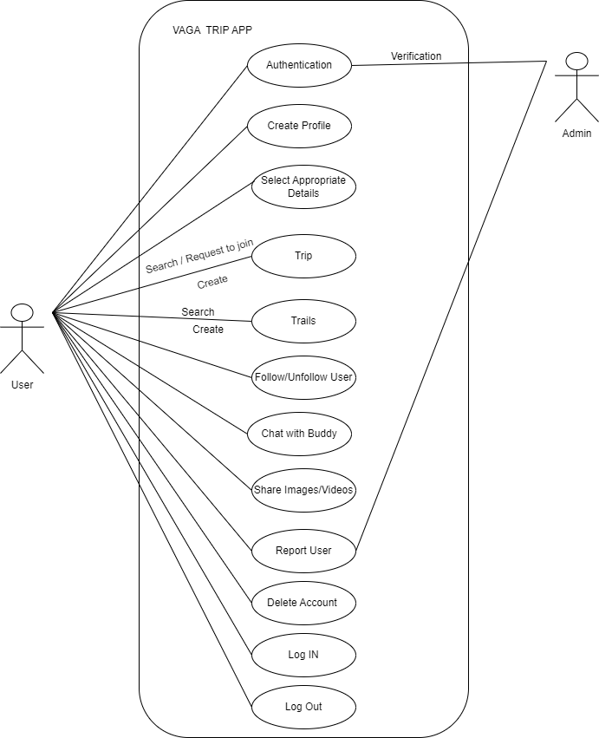

Figure 2.4.1 Use case Diagra

**2.4.2 DFD (Data Flow Diagram)**

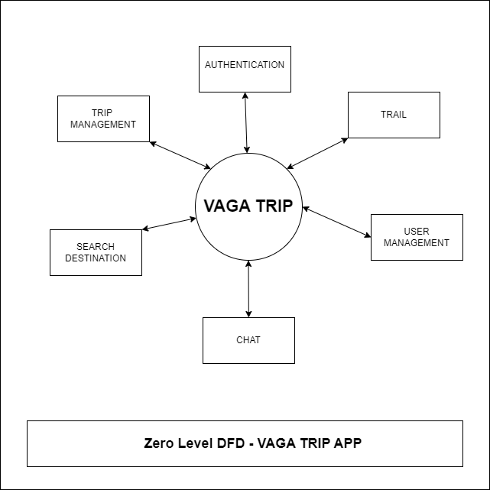

Figure 2.4.2 DFD (Data Flow Diagram)

**2.4.3 Activity Diagram**

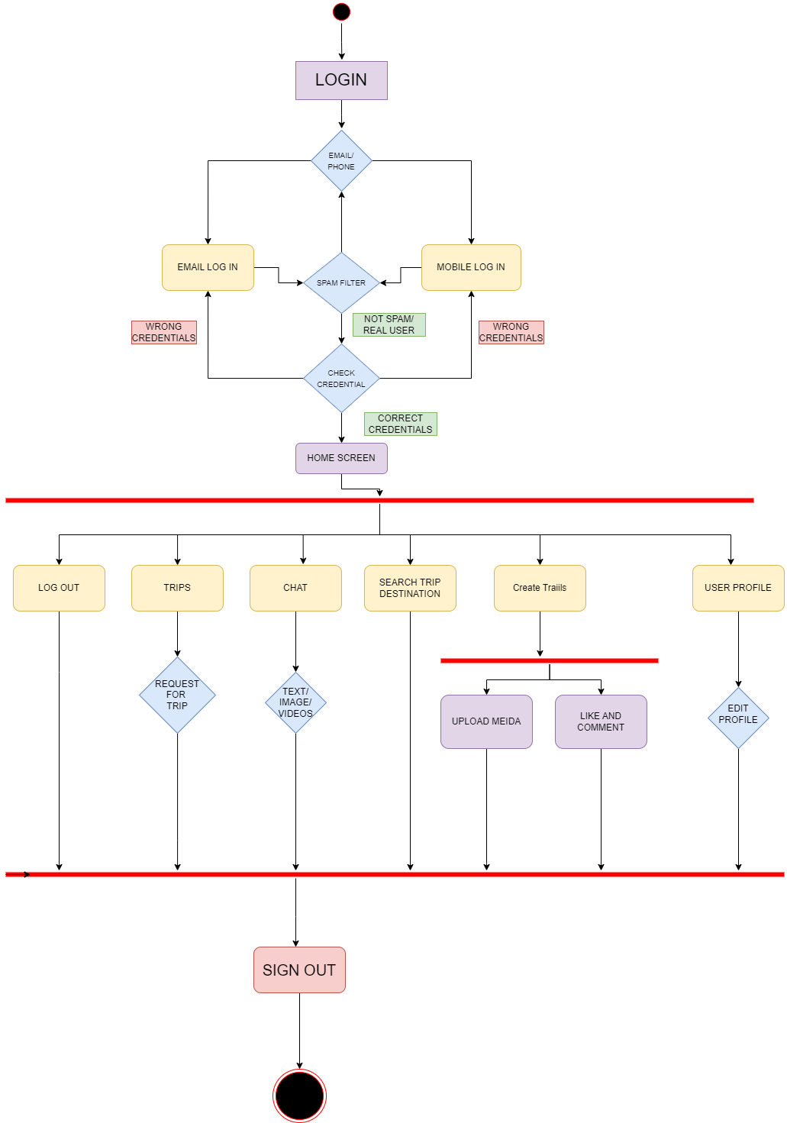

Figure 2.4.3 Activity Diagram

**2.4.4 Entity Relationship Diagram**

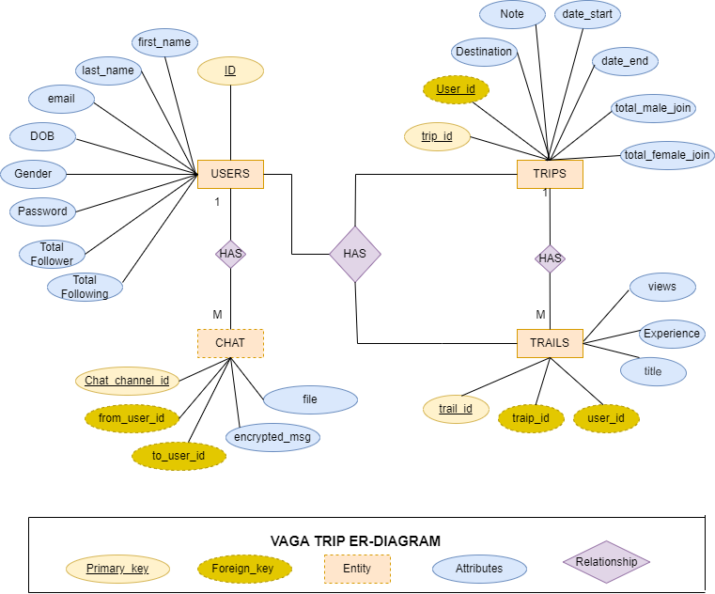

Figure 2.4.4 ER Diagram

**2.4.5 Sequence Diagram**

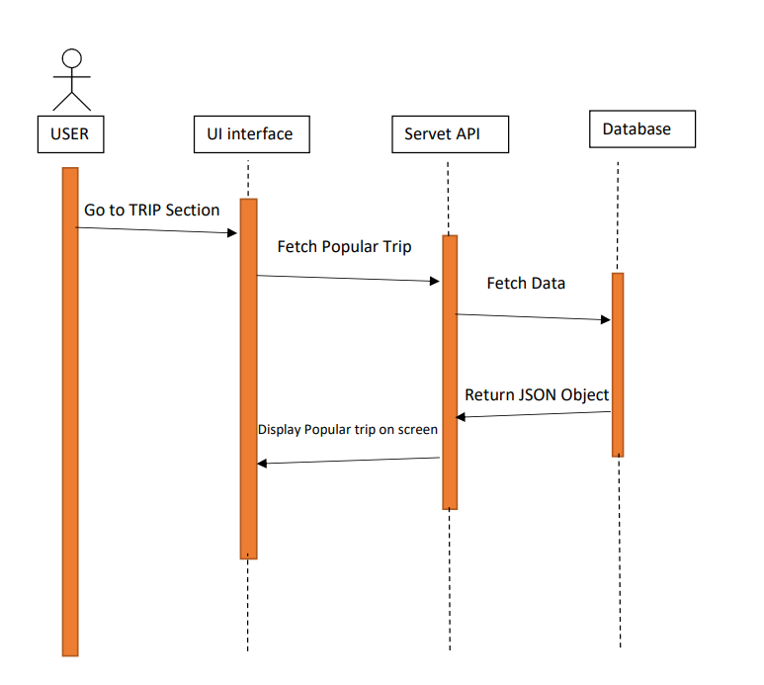

Figure 2.4.5 (a) Sequence diagram of Vaga Trip Process

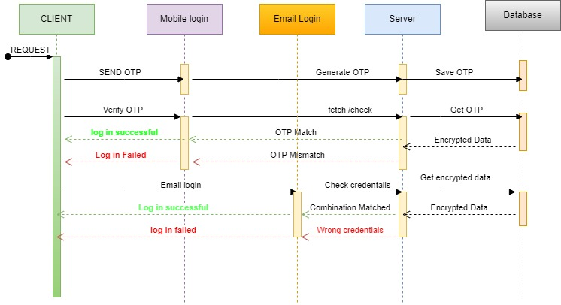

Figure 2.4.5 (b) Sequence daigram of vaga login process

**2.4.6 (a) Class Diagram**

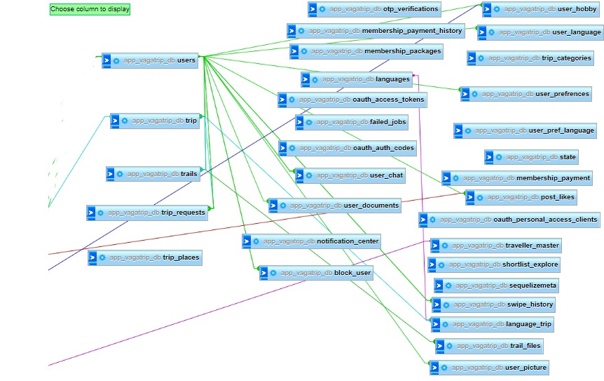

Figure 2.4.6 (a) Class Diagram(a) - Birds Eye View

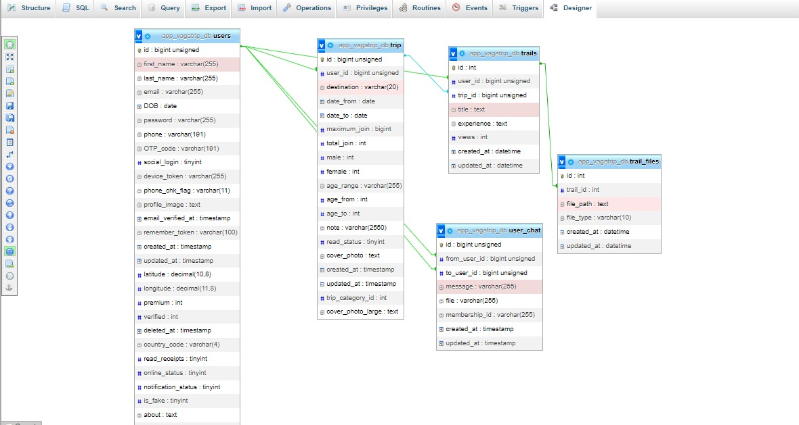

Figure 2.4.6 (b) Class Diagram (b)

**3. Implementation**

**3.1. Implemented Functionality**

1. User Registration and Login: Users can create their account on Vaga Trip by providing their basic details and can also log in with their social media accounts.
2. Search for Destinations: Users can search for destinations and view details about the location, such as its popular attractions, accommodation options, and reviews.
3. Plan and Book Trips: Users can plan and book trips by selecting their preferred travel dates, destination, and accommodation options.
4. View Trip Details: Users can view their trip details, including flight details, hotel reservations, and car rental bookings.
5. Notifications and Alerts: Users receive real-time notifications and alerts regarding their trip, including flight updates, booking confirmations, and reminders.
6. Social Sharing: Users can share their travel experiences and photos on social media platforms directly from the app.

**3.2. Results and Reports**

Vaga Trip app has over 25,000 users, is available on both Android and iOS, and offers features such as trip planning, hotel booking, flight booking, and car rental integration. The app is built using Flutter for the front-end, Node.js with ExpressJS API and Sequelize ORM for the back-end, and is hosted on AWS using RDS as a database service and EC2 for the server.

Regarding the results and reports, Vaga Trip's development team would have access to metrics such as user engagement, user acquisition, retention rate, conversion rate, revenue, and other key performance indicators (KPIs). These metrics can be analyzed to identify strengths, weaknesses, and areas for improvement of the app, and to inform future development and marketing strategies.

**SFS Project Tracker**

*Table 3.2 SFS Project tracker*

| Sr No | Epic | Story Name | Status |  |
| --- | --- | --- | --- | --- |
| **1** | **Authentication** | **Splash & Welcome screen story** | **Completed** |  |
| **2.1** | **Authentication** | **Join Now (Non-Registered user)** | **Completed** |  |
|  |  | **Front end development** | **Completed** |  |
|  |  | **Backend development** | **Completed** |  |
|  |  | **API integration** | **Completed** |  |
|  |  | **API integration** | **Completed** |  |
| **2.2** | **Authentication** | **Sign in (Already registered user)** | **Completed** |  |
|  |  | **Front end development** | **Completed** |  |
|  |  | **Backend development** | **Completed** |  |
|  |  | **API integration** | **Completed** |  |
|  |  | **API integration** | **Completed** |  |
| **3** | **Enter name view** | **For Newly Registered user** | **Completed** |  |
|  |  | **Front end development** | **Completed** |  |
|  |  | **Backend development** | **Completed** |  |
|  |  | **API integration** | **Completed** |  |
| **3.1** | **Selecting two images** | **Select Photo screen** | **Completed** |  |
|  |  | **Front end development** | **Completed** |  |
|  |  | **Backend development** | **Completed** |  |
|  |  | **API integration** | **Completed** |  |
| **3.2** | **Detail: Traveller Type** | **Screen: List of different type of traveller in list view and search button** | **Completed** |  |
|  |  | **Front end development** | **Completed** |  |
|  |  | **Backend development** | **Completed** |  |
|  |  | **API integration** | **Completed** |  |
| **4** | **Details: Languages** | **Screen: List of different type of language in list view and search button** | **Completed** |  |
|  |  | **Front end development** | **Completed** |  |
|  |  | **Backend development** | **Completed** |  |
|  |  | **API integration** | **Completed** |  |
| **5** | **Details: Hobby** | **Screen: List of different type of Hobby in list view and search button** | **Completed** |  |
|  |  | **Front end development** | **Completed** |  |
|  |  | **Backend development** | **Completed** |  |
|  |  | **API integration** | **Completed** |  |
| **5.1** | **Trip Section** | **TRIP - Trip Listing (Share, like, comment, save, follow, report, delete)** | **Completed** |  |
|  |  | **Front end development** | **Completed** |  |
|  |  | **Backend development** | **Completed** |  |
|  |  | **API integration** | **Completed** |  |
| **5.2** | **Trip Section** | **Create Trip with Detail** | **Completed** |  |
|  |  | **Front end development** | **Completed** |  |
|  |  | **Backend development** | **Completed** |  |
|  |  | **API integration** | **Completed** |  |
| **5.3** | **Trip Category** | **Show list of trips on based of category in** | **Completed** |  |
|  |  | **Front end development** | **Completed** |  |
|  |  | **Backend development** | **Completed** |  |
|  |  | **API integration** | **Completed** |  |
| **5.4** | **Explore** | **Explore – Get Trending Trips** | **Completed** |  |
|  |  | **Front end development** | **Completed** |  |
|  |  | **Backend development** | **Completed** |  |
|  |  | **API integration** | **Completed** |  |
| **5.5** | **Explore** | **Explore – Add Trips images in trails** | **Completed** |  |
|  |  | **Front end development** | **Completed** |  |
|  |  | **Backend development** | **Completed** |  |
|  |  | **API integration** | **Completed** |  |
| **6** | **Chat** | **Chat - Listing & Detail** | **Completed** |  |
|  |  | **Front end development** | **Completed** |  |
|  |  | **Backend development** | **Completed** |  |
|  |  | **API integration** | **Completed** |  |
| **6.1** | **Chat** | **Chat – video/voice call** | **Completed** |  |
|  |  | **Front end development** | **Completed** |  |
|  |  | **Backend development** | **Completed** |  |
|  |  | **API integration** | **Completed** |  |
| **7** | **Search** | **Search Trips/Trails** | **Completed** |  |
|  |  | **Front end development** | **Completed** |  |
|  |  | **Backend development** | **Completed** |  |
|  |  | **API integration** | **Completed** |  |
| **8** | **Fotter menu bar** | **Fotter Menu --> View Mode** | **Completed** |  |
|  |  | **Front end development** | **Completed** |  |
|  |  | **Backend development** | **Completed** |  |
|  |  | **API integration** | **Completed** |  |
| **9** | **Notification** | **Notification - List and Matrix** | **Pending** |  |
|  |  | **Front end development** | **Completed** |  |
|  |  | **Backend development** | **Pending** |  |
|  |  | **API integration** | **Completed** |  |
| **10** | **Home Page** | **Home page - Complete integration** | **Completed** |  |
|  |  | **Front end development** | **Completed** |  |
|  |  | **Backend development** | **Completed** |  |
|  |  | **API integration** | **Completed** |  |
| **11** | **Beta testing and Launch** | **Android and iOS** | **Pending** |  |
|  |  |  |  |  |

**3.3. Snapshots**

**1. Login Page** using facebook, Google, Apple Id along with mobile number login

|  |  |
| --- | --- |
| Figure 3.3 (a) Login Page | Figure 3.3. (b) Login with mobile number |
| Figure3.3 (c) Receive OTP in WhatsApp | Figure 3.3 (d) Receive OTP in SMS |

**2. Sign Up page**

|  |  |
| --- | --- |
| Figure 3.3 (e) Sign Up Process for Name | Figure 3.3 (f) select two photos |
| Figure 3.3 (g) After selecting two photos | Figure 3.3 (h) Selecting the best about yourself |

**3. Search Trip by Category**

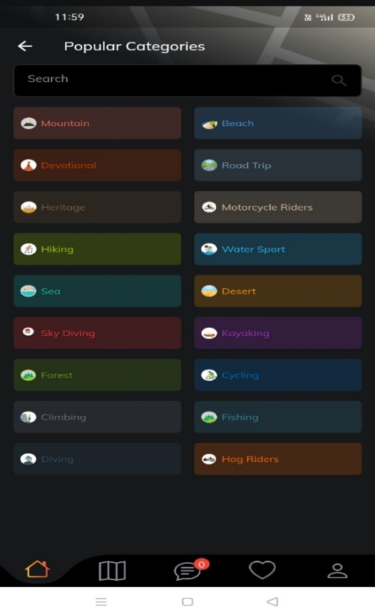

Figure 3.3 (i) Trip Category

**4. Trending trip page**

|  |  |
| --- | --- |
| Figure 3.3. (j) Trending Trips | Figure 3.3. (k) Create Trip view |

**5. Create Trail page [Story]**

|  |
| --- |
| Figure 3.3 (l) Creating Trail    Figure 3.3. (m) trails |

**6. Find travel buddy page**

|  |  |
| --- | --- |
| Figure 3.3. (n) Find buddy Swipe feature | Figure 3.3. (o) Filter Functionality |
| Figure 3.3 (p) Chat with Buddy | Figure 3.3. (q) Image/Text/Audio/Video/Voice facility |

**7. Profile**

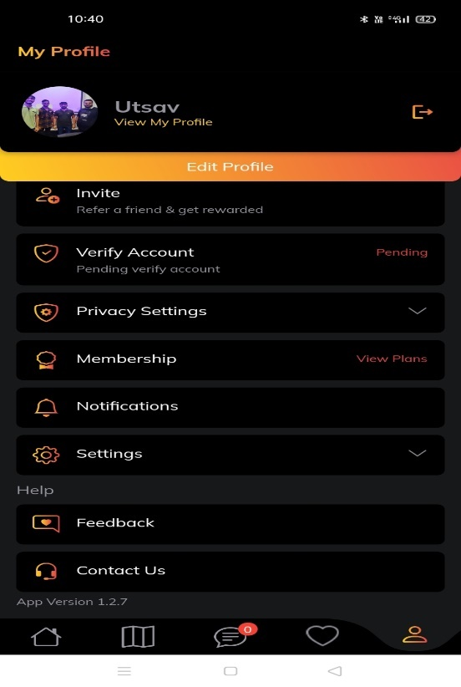

Figure 3.3 (r) My profile

**8. Verify Profile**

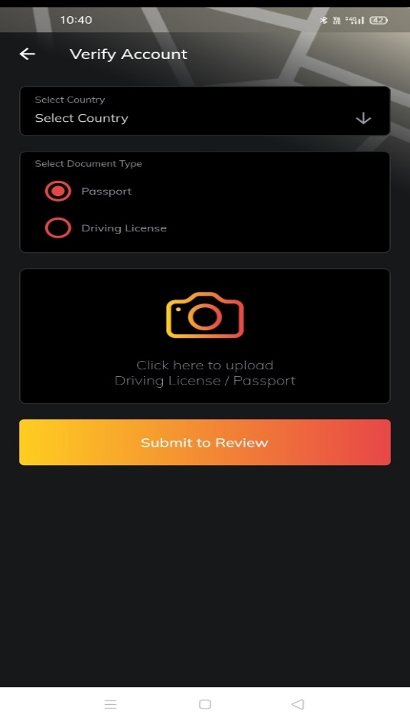

Figure 3.3. (s) Profile Verification View

**3.4. Testing and Verification**

To test and verify the Vaga Trip app, we can follow a systematic and structured approach. Here are some steps that we can take:

**1. Unit testing:** This involves testing each individual component of the app, such as classes, methods, and functions, to ensure they are functioning as intended. Automated testing tools can be used to test each unit of code and identify any errors or bugs.

**2. Integration testing**: This involves testing how the different components of the app work together. We can test how different screens, features, and functionalities interact with each other, to ensure the app is functioning as a whole.

**3. Functional testing:** This involves testing the app's features and functionalities to ensure they are working as expected. For example, we can test whether users can browse trips, search for travel buddies, communicate in the chat box, and share their travel stories.

**4. Usability testing**: This involves testing how easy and intuitive the app is to use. We can conduct user testing and gather feedback from users to improve the user experience.

**5. Performance testing**: This involves testing the app's performance, such as its speed, responsiveness, and stability. We can test the app's performance under different conditions, such as slow internet connectivity or low battery, to identify any performance issues.

**6. Security testing:** This involves testing the app's security features to ensure they are protecting user data and preventing unauthorized access.

**7. Compatibility testing:** This involves testing the app on different devices, operating systems, and screen sizes to ensure it works on all platforms.

By following these testing and verification steps, we can ensure that the Vaga Trip app is functioning as intended and providing a positive user experience

*Table 3.4 Testing Table*

|  |  |  |  |  |  |
| --- | --- | --- | --- | --- | --- |
| **Sr No** | **Feature/Screen** | **Summary** | **Type** | **Priority** | **Status** |
| **1** | **SFS** | **Delete user api should consist of deleting user content overall** | **Bug** | **Highest** | **Dev Done** |
| **2** | **SFS** | **Delete User should not close app** | **Bug** | **Highest** | **Done** |
| **3** | **Auth > Mobile Number** | **International OTP to be worked** | **Bug** | **Highest** | **Not Started** |
| **4** | **Hamburger > Opportunities** | **Feedback page should be visible in profile view** | **Bug** | **Highest** | **Done** |
| **5** | **Profile Section >> post** | **In my Profile >> in trip >> when User request for trip >> the app crashes** | **Bug** | **Highest** | **Done** |
| **6** | **Profile Section** | **Update profile photo >> User should be able to update profile photo** | **Bug** | **Highest** | **Done** |
| **7** | **Profile Section** | **Contact us Page not accessible** | **Bug** | **Highest** | **Done** |
| **8** | **Profile Section** | **In my Profile >> Invite >> Message app link is not working with onelink.to** | **Bug** | **Highest** | **Done** |
| **9** | **TRIP Section** | **In trip section when user fills details to create trip at the end when clicks on create button the app crash** | **Bug** | **Highest** | **Done** |
| **10** | **Trail Section** | **User not able to see popular trails on first priority on screen** | **Bug** | **Highest** | **Done** |
| **11** | **Chat section** | **In chat Section Profile >> in Videos >> the video dont play and it also gets stretched.** | **Bug** | **Highest** | **Done** |
| **12** | **Chat Section** | **In chat Section Profile >> Sending images >> images appers to black** | **Bug** | **Highest** | **Done** |
| **13** | **Travel Buddy** | **Swipe Feature stopped working** | **Bug** | **Highest** | **Done** |
| **14** | **Travel Buddy** | **User photo not visible and slow loadtime** | **Bug** | **Highest** | **Done** |
| **15** | **Travel Buddy** | **Folllow/ Follower not showing any increment** | **Bug** | **Highest** | **Done** |

**4. Conclusion**

**4.1. Summary of the results**

Vaga Trip is a mobile application designed to connect travel enthusiasts from around the world. The app's primary aim was to develop an Android app that serves as a travel guide for users during their journeys. Vaga Trip offers new functions that are not commonly found in traditional travel apps, specifically user interaction and trip sharing features.

With Vaga Trip, users can browse a variety of trips and destinations based on their interests, dates, and budget. Once a user finds a trip that matches their preferences, they can easily request to join the trip and communicate with the trip organizer in the chat box. Additionally, users can search for travel buddies based on common interests, travel destinations, and dates.

The app also includes a feature for sharing trip stories, where users can upload pictures and write descriptions of their travel experiences to inspire and inform other travelers. This feature allows users to share their unique perspectives on destinations, experiences, and cultures.

The future scope of work for Vaga Trip could involve integrating hotel booking, flight booking, and car rental features into the app. By integrating these features, users can enjoy a more seamless and convenient travel experience without having to switch between multiple apps or websites. However, some considerations for each integration include selecting reliable partners, ensuring the accuracy of information, and implementing secure payment options.

**4.2. Advantages of your work/results/methodologies**

**1. User-friendly Interface:** The app has a simple and intuitive interface, making it easy for users to navigate and find what they need. This helps to enhance the user experience, and keep users engaged with the app.

**2. Efficient Development:** The use of Flutter and Node.js with ExpressJS API and Sequelize ORM helped in achieving efficient development of the app. Flutter allowed for faster development of the front-end, while Node.js with ExpressJS API and Sequelize ORM provided a robust and scalable back-end.

**3. Cloud Hosting:** The app is hosted on AWS cloud, which offers a reliable and scalable infrastructure. This ensures that the app can handle a large number of users and traffic, without any downtime.

**4. Availability on Both Platforms:** The app is available on both Android and iOS, which means it can reach a wider audience. This increases the potential user base and provides more opportunities for growth.

**5. Integration Potential:** The app has the potential to integrate with other services such as hotel booking, flight booking, and car rental. This would further enhance the user experience and provide more value to users.

**6. User Base:** With over 25,000 users, the app has a substantial user base. This provides social proof and credibility, which can help to attract new users.

Overall, the work, results, and methodologies used in developing the Vaga Trip app have resulted in a user-friendly, efficient, and scalable app, with a significant user base and potential for further growth.

**4.3. Scope of future work.**

The future scope of work for Vaga Trip could involve integrating hotel booking, flight booking, and car rental features into the app. Here are some potential benefits and considerations of each integration:

**1. Hotel Booking Integration:**

By integrating hotel booking into the Vaga Trip app, users can easily search and book hotels in their desired location without having to switch to another app or website. This feature can make trip planning more convenient and efficient for users. Additionally, the app could offer exclusive deals and discounts on hotels, which can attract more users to the platform. Some considerations for hotel booking integration include selecting reliable hotel partners, ensuring the accuracy of hotel information, and implementing secure payment options.

**2. Flight Booking Integration:**

Integrating flight booking into the Vaga Trip app can offer similar benefits as hotel booking integration, including convenience and potential cost savings for users. Users can search and book flights directly from the app, and receive real-time flight updates and notifications. The app could also provide personalized flight recommendations based on users' travel preferences and past booking history. However, flight booking integration may involve more complex technical requirements and regulatory compliance considerations.

**3. Car Rental Integration:**

Integrating car rental into the Vaga Trip app can provide users with a seamless travel experience, especially for those who prefer self-driving or road trips. Users can search and book rental cars in their destination, and receive pick-up and drop-off information directly from the app. The app could also offer user-friendly navigation and trip planning tools for drivers. Some considerations for car rental integration include partnering with reliable car rental companies, providing accurate car information and pricing, and ensuring proper insurance coverage.

**4.4. Unique Features of your Innovation/Project**

Vaga Trip app can make a significant impact on people's lives by providing them with a comprehensive platform to connect with other travel enthusiasts, find new adventures, and share their travel experiences. Here are some ways in which the app can contribute to the greater good:

**1. Promoting Cultural Exchange:**

By enabling users to connect with travel buddies and share their travel experiences, Vaga Trip app can promote cultural exchange and understanding. Users from different backgrounds and regions can learn from each other's perspectives and explore new cultures together. This can foster empathy, respect, and openness, which are essential for building a more tolerant and inclusive society.

**2. Supporting Local Tourism:**

Vaga Trip app can support local tourism by promoting lesser-known destinations and small businesses. Users can discover off-the-beaten-path places and experiences, which can benefit local communities and economies. Additionally, the app can partner with local tourism authorities and organizations to offer sustainable and responsible travel options.

**3. Reducing Environmental Impact:**

Vaga Trip app can contribute to reducing the environmental impact of travel by promoting sustainable and eco-friendly travel options. Users can find and join eco-tours, volunteer programs, and other responsible travel initiatives that minimize their carbon footprint and preserve natural resources. The app can also encourage users to adopt sustainable travel practices, such as reducing plastic waste, conserving water, and using public transportation.

**4. Enhancing Social Well-being:**

Travel can have a positive impact on mental and emotional well-being, as it can reduce stress, improve mood, and boost creativity. Vaga Trip app can enhance social well-being by providing users with opportunities to meet new people, form meaningful connections, and enrich their social lives. Additionally, the app can offer travel-related resources and support for mental health and well-being.

**References**

[1] A. B. Yahaya, "A Distributed Information System for Tourists: A Case Study of Niger State Tourism Destinations," Master's thesis, unpublished, 2010.

[2] "Literature Review," [Online]. Available: https://libguides.usc.edu/writingguide/literaturereview.

[3] S. M. Abdulhamid and G. Usman, "Destination Information Management System for Tourist," arXivpreprint arXiv:1402.1243, 2014.

[4] A. H. Agboola, A. J. Gabriel, E. O. Aliyu, and B. K. Alese, "Development Of A Fuzzy Logic Based Rainfall Prediction Model," International Journal of Engineering and Technology, vol. 3, no. 4, pp. 397-404, April 2013.

[5] B. Wong, I. Stoyanov, and E. G. Sirer, "Octant: A Comprehensive Framework for the Geolocalization of Internet Hosts," in Proceedings of the Symposium on Networked System Design and Implementation, Cambridge, Massachusetts, April 2007.

[6] L. Cao and F. Tay, "Financial Forecasting Using Support Vector Machines," Neural Comput & Application, vol. 10, pp. 184-192, 2001.

[7] D. Li, J. Cheny, C. Guo, Y. Liu, J. Zhangy, Z. Zhang, and Y. Zhang, "IP-Geolocation Mapping for Involving Moderately-Connected Internet Regions," Technical Report, 2009.

[8] D. Chatzopoulou and M. Kokkodis, "IP Geolocation," Computer Science and Engineering Dept UC Riverside Technical Report, 2007.

[9] H. L. S. Berger and F. Lehner, "Location-based information services in the tourist industry," Journal of Information Technology & Tourism, vol. 5, pp. 243-256, 2003.

[10] "What is Cloud Computing?" [Online]. Available: https://aws.amazon.com/what-is-cloud-computing/?nc2=h_ql_le_int_cc.

[11] B. Merchant, "How to Create and Test a Node.js Blog API," [Online]. Available: https://medium.com/@benmerchant/how-to-create-and-test-a-node-js-blog-api-819170280abd.

[12] "Digitization and Millennials are Redefining the Travel Industry," [Online]. Available: https://www.televisory.com/blogs/-/blogs/digitization-and-millennials-are-redefining-the-travel-industry.

[13] D. C. Ukpabi and H. Karjaluoto, "Consumers' Acceptance of Information and Communications Technology in Tourism: A Review," Telematics and Informatics, vol. 34, no. 5, pp. 618-644, 2017.